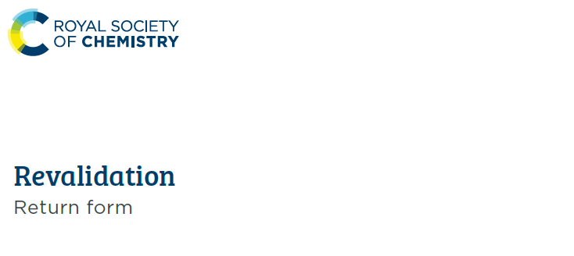
Name
RSC membership number
Email address
Which award are you revalidating?
I have attached my CV ☐

Dr David Moulding  QP Officer  Royal Society of Chemistry | Telephone: 0207 440 3314  Email: qp@rsc.org  Website: http://rsc.li/qp
Please return to:

Section 1: Professional Development Activities
Include information of up to four activities in any three or more of the five categories (a – e) below. Complete two categories out of five (a-e) if you are retired
List your CPD activities from the last 12 months | Reflect upon how these activities have benefitted the quality of your practice.  You should aim to write between 200-500 words. | Explain how your CPD activities have benefitted the users of your work | If helpful, you may indicate which award standards/ attributes (RSciTech, RSci, CSci, CChem, CEnv, or CSciTeach) these activities support.  See the guidance document for each of the award standards. | Approximate date(s) | Is evidence for this activity available, if requested?  If yes, please x the check box
- Work based, experiential learning (e.g. supervising staff/students, training initiatives, report writing)
- e.g. Attended ‘Sustainability in the laboratory’ training course and implemented several initiatives as a result | There are three things that I learned on this course, which have improved the quality of my practice. These are… and they have improved my practice by… | My colleagues have noted a number of ways that improvements I have made following this course have improved their day to day working lives. For example… | B2: Take responsibility for safe and sustainable working practices and contribute to their evaluation and improvement | June 2020 | ☒
 |  |  |  |  | ☐
 |  |  |  |  | ☐
 |  |  |  |  | ☐
 |  |  |  |  | ☐
- Professional activity (e.g. involvement in a professional body, mentoring)
- e.g. Became an RSC assessor for professional awards | As part of the process to become an assessor, I had to attend training. This entailed… I am now able to… | As a result of becoming an award assessor, I am able to support colleagues in…. | C1: Demonstrate effective and appropriate communication skills | April 2020 | ☒
 |  |  |  |  | ☐
 |  |  |  |  | ☐
 |  |  |  |  | ☐
 |  |  |  |  | ☐
- Formal / Educational learning (e.g. writing articles/papers, further education, internal procedures / reports)
- e.g. Developed a new SOP for my department | Contributing to a new SOP meant I was able to apply my skills in… and develop my knowledge and ability to… | Having a more appropriate and relevant SOP means the work undertaken by my team is… The customers of our work are now… | D4: Contribute to continuous process improvement | August 2020 | ☒
 |  |  |  |  | ☐
 |  |  |  |  | ☐
 |  |  |  |  | ☐
 |  |  |  |  | ☐
- Self-directed learning (e.g. reading journals, reviewing books / articles)
- e.g. Signed up to RSC journal Faraday Discussions and attended related online sessions | I found it beneficial for my working knowledge to read more and attend sessions on… I also learnt more about… which I can apply in this way… | By staying up-to-date with developing areas of physical chemistry, I can ensure I am providing users of my work and my colleagues with… | E2: Maintain and enhance competence in own area of practice through professional  development activity | February 2020 | ☐
 |  |  |  |  | ☐
 |  |  |  |  | ☐
 |  |  |  |  | ☐
 |  |  |  |  | ☐
- Other (e.g. voluntary work, public service)
- e.g. Volunteered at an online school careers fair | I enjoyed the opportunity to develop and practice my communication skills, which I apply in… | Being able to explain scientific concepts to a lay audience benefits the users of my work because… |  | July 2020 | ☐
 |  |  |  |  | ☐
 |  |  |  |  | ☐
 |  |  |  |  | ☐
 |  |  |  |  | ☐

Section 2: Future CPD plans
Please provide details of future CPD activities you plan to undertake, or areas you wish to develop within the next 5 years. Relate these to the standards/attributes of your award – for example, to incorporate skills you may not have had a chance to develop this year.
Please indicate if you would like to receive a confidential, one-to-one consultation with our career management specialists. ☐

Declaration
I hereby agree that the information given is correct and supports my award revalidation as part of the audit.
Please tick the box below to indicate your agreement to the declaration.
I agree to the declaration
Print Name:
Date:

RSC Register of Eligible Qualified Persons
The RSC operates two Qualified Persons registers. The first is the Complete Register, which is a list of all those who are still eligible to act as a Qualified Person and have qualified through the RSC. At a minimum this will contain your name, year of registration and year of most recent CPD submission. This list is not made public and will only be shared with the Royal Society of Biology, (RSB) the Royal Pharmaceutical Society (RPS), the Medicine and Healthcare products Regulatory Agency (MHRA) and the Veterinary Medicines Directorate (VMD) when it is appropriate and/or required to do so.
The second list is the Web Register, which is published on the RSC website (http://rsc.li/qp). Appearing on this list is entirely optional, as is the amount of information that you would like to be present on this list. If you appear on the list, we will also include your year of registration and year of most recent CPD submission.
Using the table below, please write down the details you wish to appear on both registers:
Details you wish to be shown on the Complete Register | Details you wish to be shown on the Web Register

Please also answers the below questions. We use your answers for internal informational purposes only.
Are you named as a QP on a Manufacturer’s Licence?
yes no

Are you actively releasing product?
yes no

